**1_What is the total quantity required for each category?**

1. **Skincare**: 2,099
2. **Haircare**: 1,480
3. **Cosmetics**: 1,343

**2_Total revenue by product type:**

1. **Cosmetics**: 161,521.27
2. **Haircare**: 174,455.39
3. **Skincare**: 241,628.16

**3_Most commonly used shipping methods:**

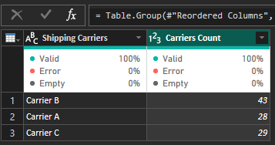

**4_Total shipping cost for each carrier:**

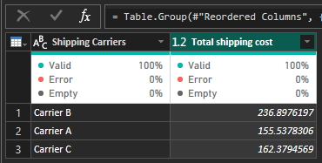

**5_ What is the average customer lead time per location?**

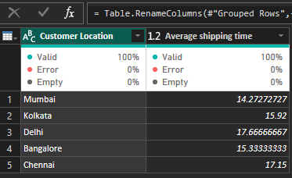

**6_What is the average price of products per Supplier?**

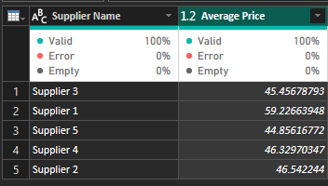

**7_What is the total production volume per Product type?**

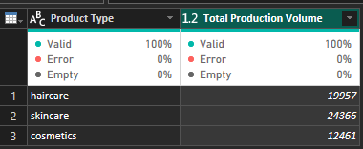

**8_What is the average manufacturing lead time per supplier?____**

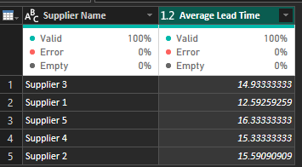

**9_What is the total manufacturing cost per product type?**

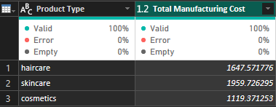

**10_What are the Top 10 products (SKUs) by total revenue?**

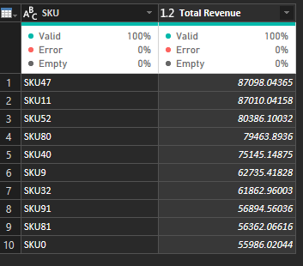

**11_What is the total number of orders per shipping carrier?____**

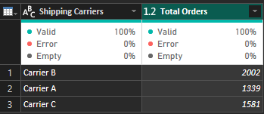

**12_What are the most used transformation modes?**

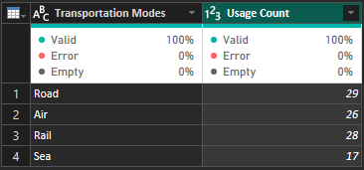

**13_What is the average shipping cost per route?___**

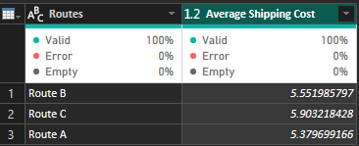

**14_What is the total quantity of products ordered per SKU?**

**Note:**

**A sample was taken from Power Query to answer this question, but the complete solution will be through the dashboard.**

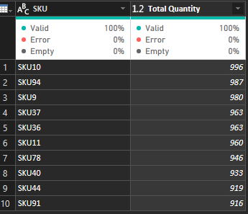

**15_What is the stock level per SKU?**

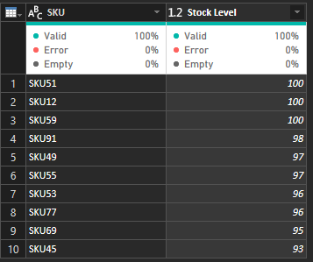

**Note:**

**A sample was taken from Power Query to answer this question, but the complete solution will be through the dashboard.**

**16_What is the average defect rate per SKU?**

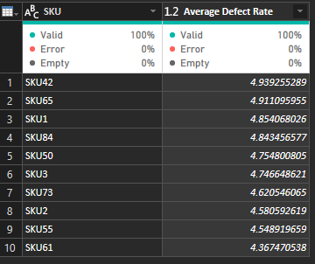

**17_How many available products are there per Demographic?**

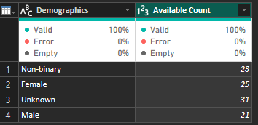

**18_What is the total cost of inventory per supplier lead time?**

**Note:**

**A sample was taken from Power Query to answer this question, but the complete solution will be through the dashboard.**

